REALME HTML



SMART PHONES PAGE

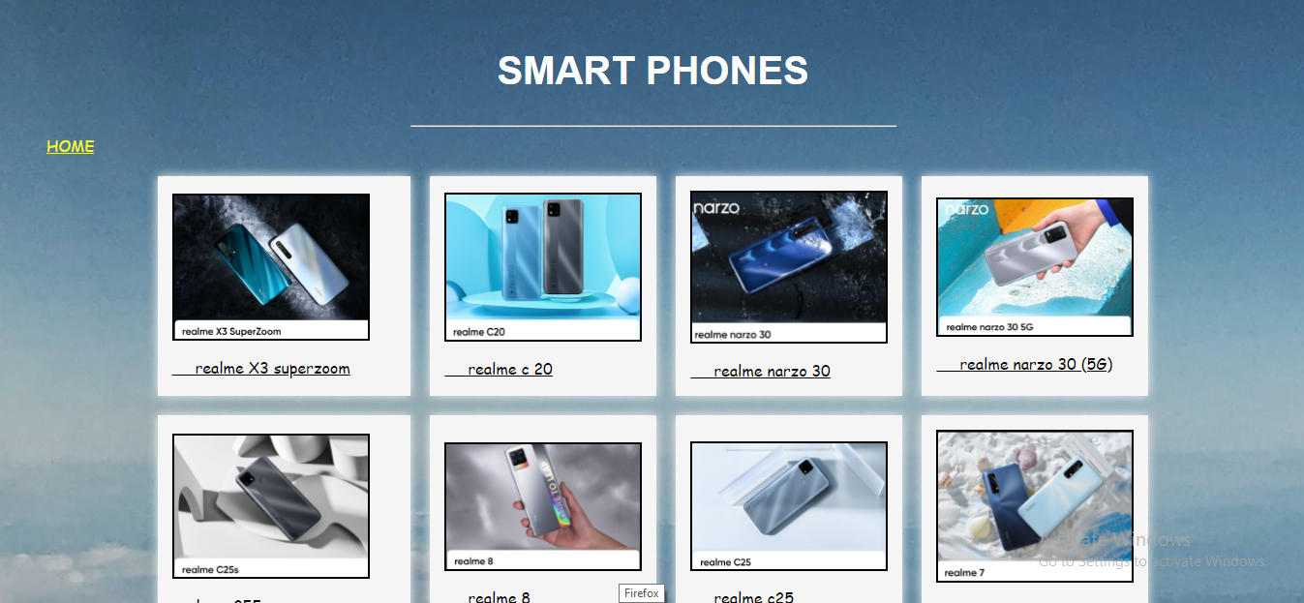

AUDIO DEVICE SECTION

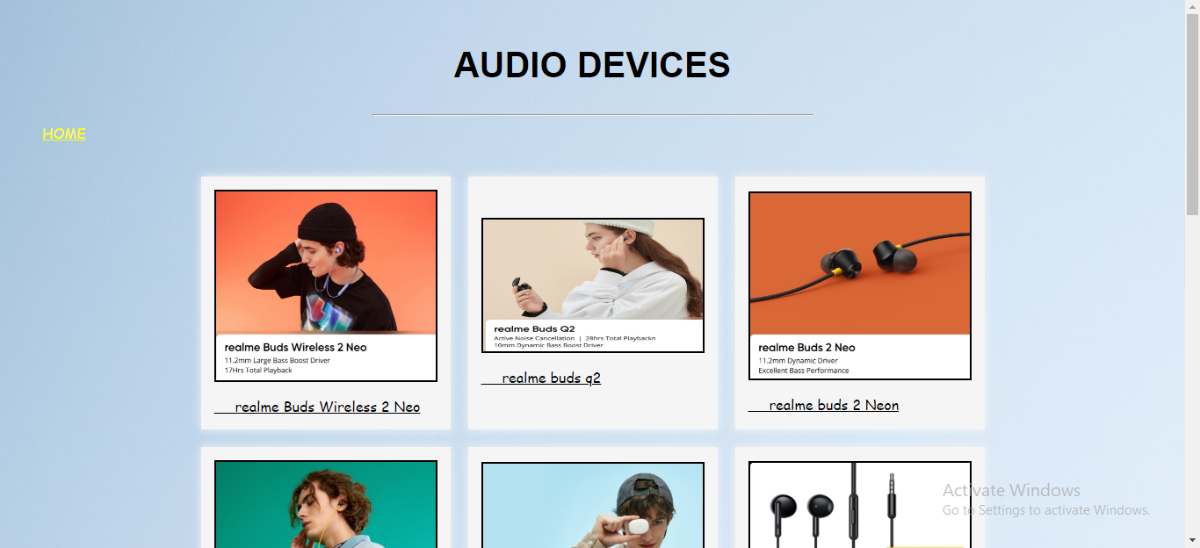

ACESSORIES DEVICES PAGE

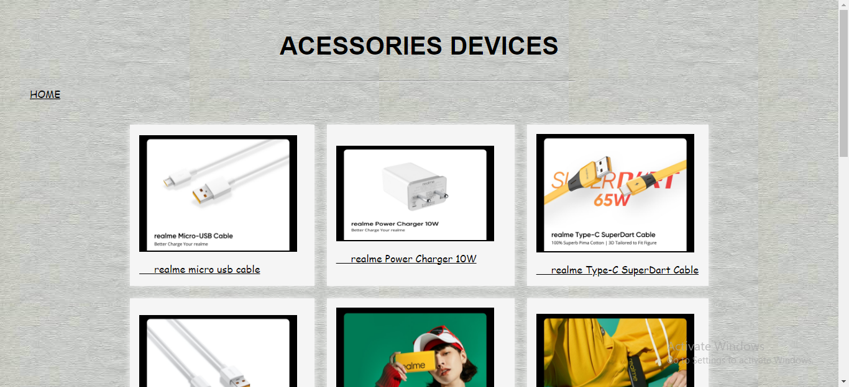

SMART LIFE SECTION PAGE

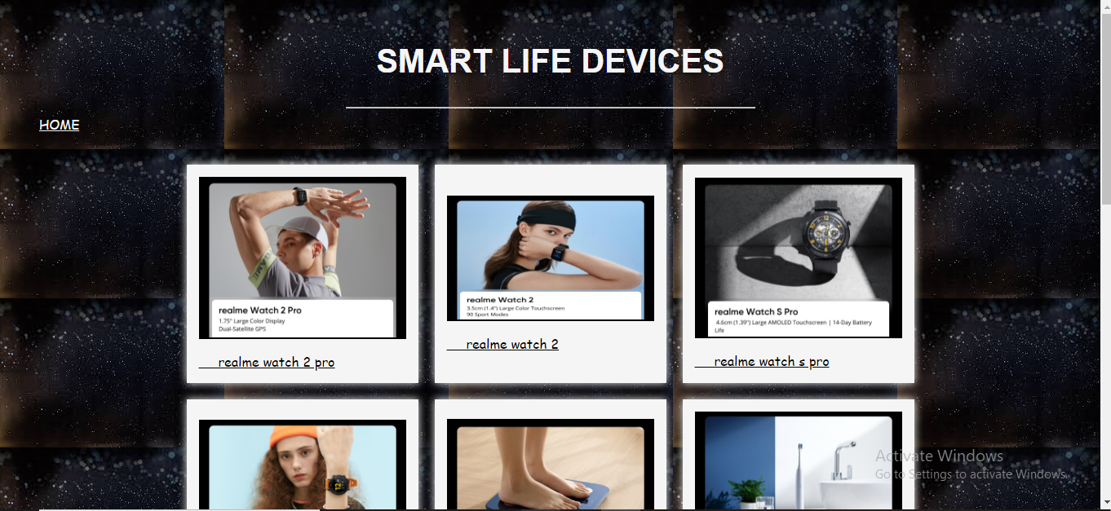

SMART TV SECTION PAGE

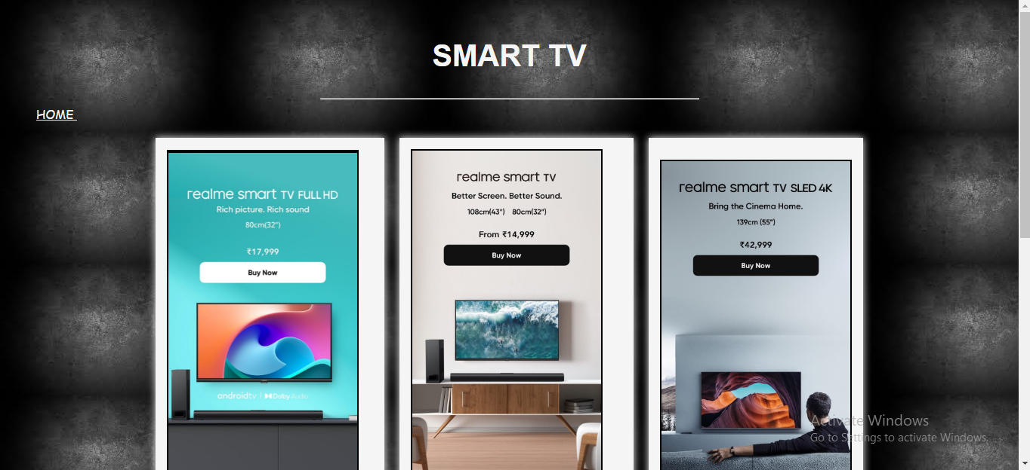

ROLLING IMAGES FEATURES



LOG IN PAGE

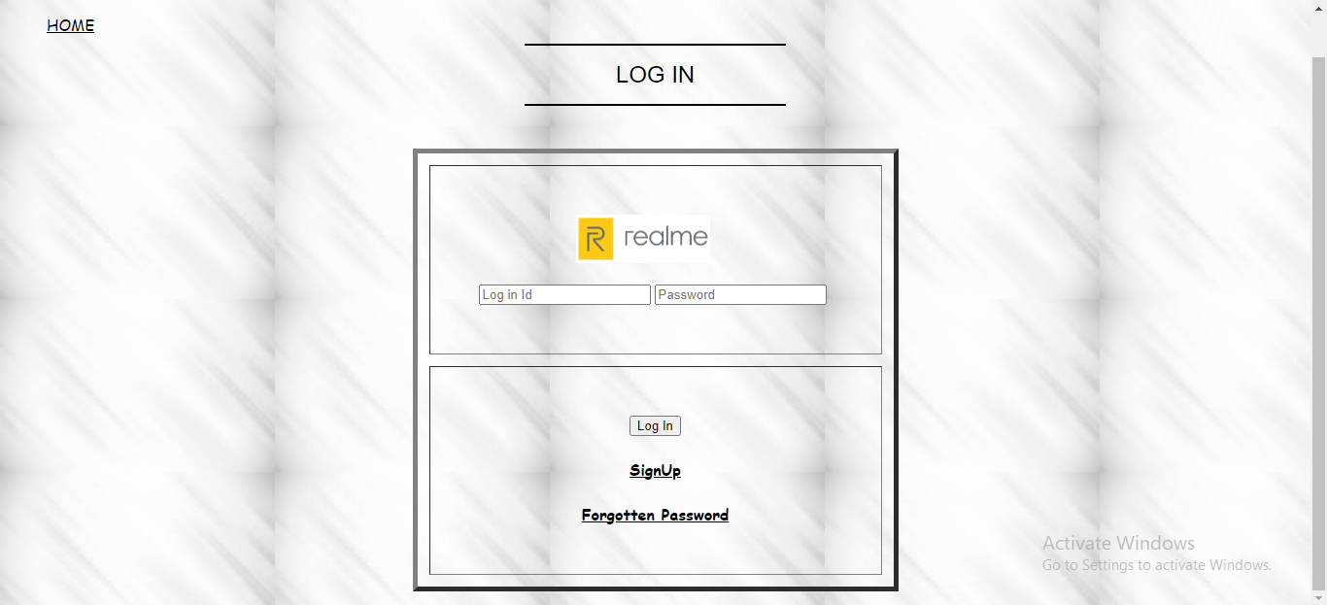

SIGN UP PAGE

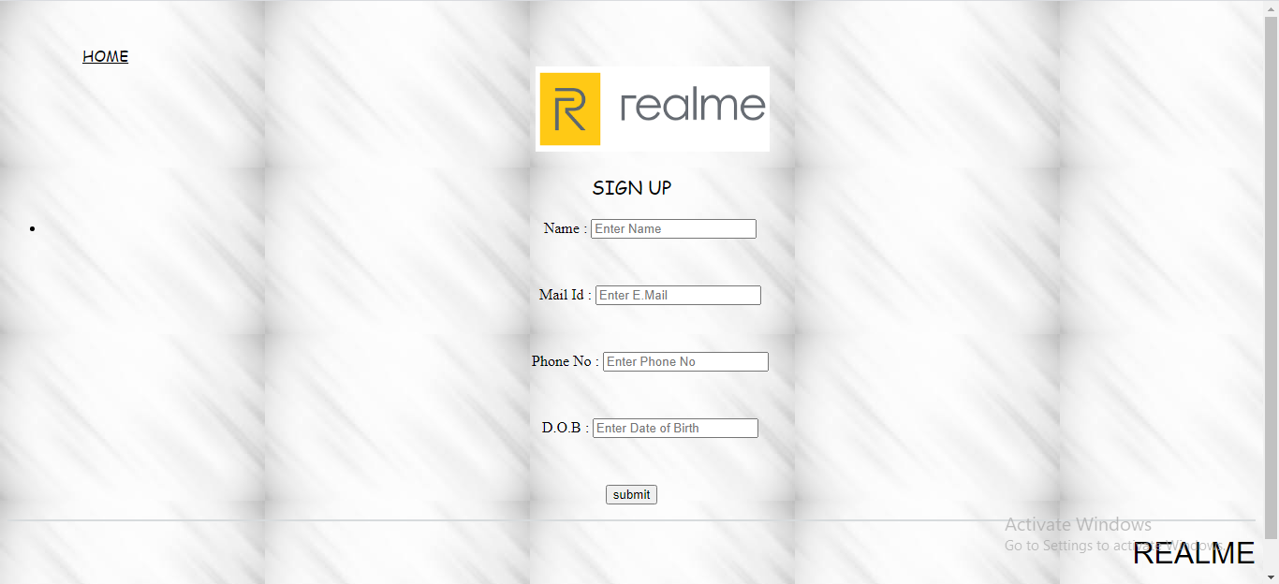

FORGOTTEN PASSWORD PAGE

